The Science in Indian Mythology

-Karun M, SRM University NCR Campus

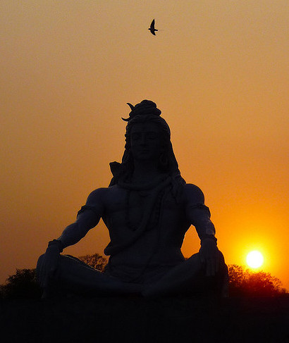

In an era like this, where people race against time and where technological advancements have reached beyond an average human imagination; why not set things apart and think about the time before any science and technology was brought to notice. In this article I have elucidated some unbelievable correlation between Hindu mythological stories and well established scientific facts.

A few excerpts from the Mahabharata have caused doubts in the minds of historians, indicating the possibility of nuclear weapons being used in the Mahabharata war or post-war. This fire of suspicion has further been fuelled by the recent discoveries of green glass and many radioactive samples in certain excavations, in India, which apparently were associated with the Mahabharata war. Green glass is said to form when sand melts at very high temperatures prevalent in Nuclear Explosions

The science of cloning was well known and practised during the Mahabharata times. As per Dr. B.G. Matapurkar, the Kauravas "were products of technology that modern science has not even developed yet". He said that according to the description in Mahabharata, the Kauravas were created by splitting the single embryo into 100 parts and growing each part in a separate container. In other words, "they not only knew about test-tube babies and embryo splitting but also had the technology to grow human foetuses outside human body."

In Mahabharata, when Subhadra was pregnant, Arjun told her the secret of entering the Chakravyuh. When he was explaining the exit procedure, Subhadra fell asleep. Hence Abhimanyu learned the entrance procedure while he was in Subhadra's womb but did not learn the exit strategy. There was a time when people criticized this concept. But modern science says that it is very much possible. In his book "Right Brain Education in Infancy" Dr. Makoto Shichida, says, the right brain is active during gestation.

Ramasethu (the Lanka Bridge in Ramayana) is an engineering masterpiece. From scientific point of view, the technology once existed to make stones float on water and the architect like Nal and Neel were two architects advanced in building a bridge from India to Sri Lanka within 5 days with the help of dedicated work force of million Vanaras. Even in Valmiki Ramayana, there is a concept of civil engineering in building this bridge. This bridge was not constructed just by throwing stone with lord name but there were many engineering methods.

Two lines of “Hanuman Chalisa" computes the distance of earth from sun with great simplicity and that too quite accurately - जुग सहस्त्र योजन पर भानु, लील्यो ताहि मधुर फल जानू (Juug Sahastra Yojan Par Bhanu, Lilyo taahi madhur fal jaanun). This means that Sun (Bhanu) is at a distance of Juug Sahastra Yojans (जुग सहस्त्र योजन- Distance Unit in Hindi). According to conversion practices that are in use as per Hindu Vedic Literature - 1Juug= 12000; Sahastra= 1000; 1Yojan=8 Miles. Thus 12000 X 1000 X 8 = 96,000,000 miles. 1 mile= 1.6 km. This means 153,600,000 Km. In the 17th century two scientists Giovanni and Richer have calculated the distance of sun from earth accurately and real close (at 140 million kilometres) to now officially declared figures.

If we look into ancient texts we can find a number of references to time travelling. In Hindu mythology, there is the story of King Raivata Kakudmi who travels to meet the creator Brahma. Even if this trip didn’t last long, when Kakudmi returned back to Earth, 108 Yugas had passed on Earth, and it is thought that each Yuga represents about 4 million years. The explanation Brahma gave to Kakudmi is that time runs differently in different planes of existence.

Such are the unbelievable evidences of ancient times that clearly correlate to the present day sciences. There may still be many more evidences. Are these evidences just a coincidence or really a matter of consideration it’s something for the readers to ponder on.